**Send XML Payload in REST Assured, Parse XML Response in REST Assured and Parse JSON Response in REST Assured**

**XML Payload**

**Source code**

package RestAssuredScripts;

import static io.restassured.RestAssured.*;

import org.hamcrest.Matchers;

import org.testng.annotations.Test;

import io.restassured.http.ContentType;

public class Script05PayloadXML {

@Test

public void payloadXML()

{

String xmlrequestBody = "<?xml version=\"1.0\" encoding=\"UTF-8\"?>\r\n"

+ "<Pet>\r\n"

+ " <id>0</id>\r\n"

+ " <Category>\r\n"

+ " <id>0</id>\r\n"

+ " <name>string</name>\r\n"

+ " </Category>\r\n"

+ " <name>doggie</name>\r\n"

+ " <photoUrls>\r\n"

+ " <photoUrl>string</photoUrl>\r\n"

+ " </photoUrls>\r\n"

+ " <tags>\r\n"

+ " <Tag>\r\n"

+ " <id>0</id>\r\n"

+ " <name>string</name>\r\n"

+ " </Tag>\r\n"

+ " </tags>\r\n"

+ " <status>available</status>\r\n"

+ "</Pet>";

given()

.baseUri("https://petstore.swagger.io")

.basePath("/v2/pet")

.contentType(ContentType.XML)

.accept("application/xml")

.body(xmlrequestBody)

.when().post() // execute post request

.then()

.statusCode(200)

.body("Pet.name", Matchers.equalTo("doggie"))

.log().all();

}

}

**Output**

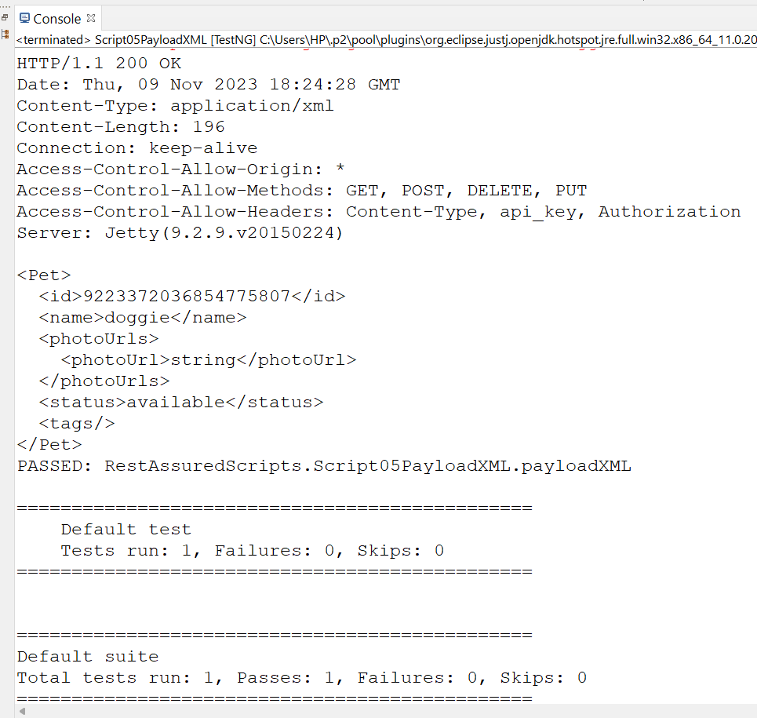

**JSON Payload**

**Source code**

package RestAssuredScripts;

import org.json.JSONObject;

import org.junit.Ignore;

import org.testng.annotations.Test;

import static org.hamcrest.Matchers.*equalTo*;

import io.restassured.RestAssured;

public class Script04PayloadJSON {

@Test

public void postusingJSON()

{

JSONObject body = new JSONObject();

body.put("name", "Pruthvi");

body.put("salary", "16573");

body.put("age", "23");

RestAssured.*given*()

.baseUri("https://dummy.restapiexample.com/api/v1")

.contentType("application/json")

.body(body.toString())

.when().post("/create")

.then()

.statusCode(200).log().all();

}

}

**Output**

